**Manually Tomcat installation on EC2 instance**

**Pre-requisites**

1. EC2 instance with Java v1.8.x

**Install Apache Tomcat**

1. Download tomcat packages from <https://tomcat.apache.org/download-80.cgi> onto /opt on EC2 instance
2. # Create tomcat directory
3. cd /opt
4. wget http://mirrors.fibergrid.in/apache/tomcat/tomcat-8/v8.5.35/bin/apache-tomcat-8.5.35.tar.gz

tar -xvzf /opt/apache-tomcat-8.5.35.tar.gz

1. give executing permissions to startup.sh and shutdown.sh which are under bin.
2. chmod +x /opt/apache-tomcat-8.5.35/bin/startup.sh

shutdown.sh

1. create link files for tomcat startup.sh and shutdown.sh
2. ln -s /opt/apache-tomcat-8.5.35/bin/startup.sh /usr/local/bin/tomcatup
3. ln -s /opt/apache-tomcat-8.5.35/bin/shutdown.sh /usr/local/bin/tomcatdown

tomcatup

**Check point :**

access tomcat application from browser on port 8080

* http://<Public_IP>:8080

Using unique ports for each application is a best practice in an environment. But tomcat and Jenkins runs on ports number 8080. Hence lets change tomcat port number to 8090. Change port number in conf/server.xml file under tomcat home

cd /opt/apache-tomcat-8.5.35/conf

# update port number in the "connecter port" field in server.xml

# restart tomcat after configuration update

tomcatdown

tomcatup

**Check point :**

Access tomcat application from browser on port 8090

* http://<Public_IP>:8090

1. now application is accessible on port 8090. but tomcat application doesnt allow to login from browser. changing a default parameter in context.xml does address this issue
2. #search for context.xml

find / -name context.xml

1. above command gives 3 context.xml files. comment () Value ClassName field on files which are under webapp directory. After that restart tomcat services to effect these changes
2. tomcatdown

tomcatup

1. Update users information in the tomcat-users.xml file goto tomcat home directory and Add below users to conf/tomcat-user.xml file
2. <role rolename="manager-gui"/>
3. <role rolename="manager-script"/>
4. <role rolename="manager-jmx"/>
5. <role rolename="manager-status"/>
6. <user username="admin" password="admin" roles="manager-gui, manager-script, manager-jmx, manager-status"/>
7. <user username="deployer" password="deployer" roles="manager-script"/>

<user username="tomcat" password="s3cret" roles="manager-gui"/>

1. Restart serivce and try to login to tomcat application from the browser. This time it should be Successful

Following is screen shot step wise step-

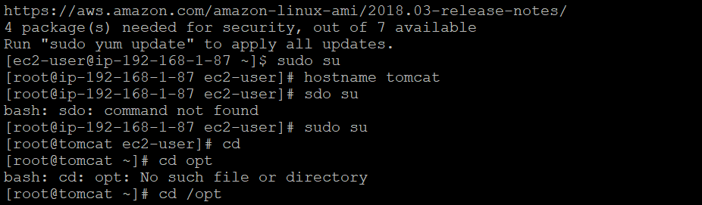

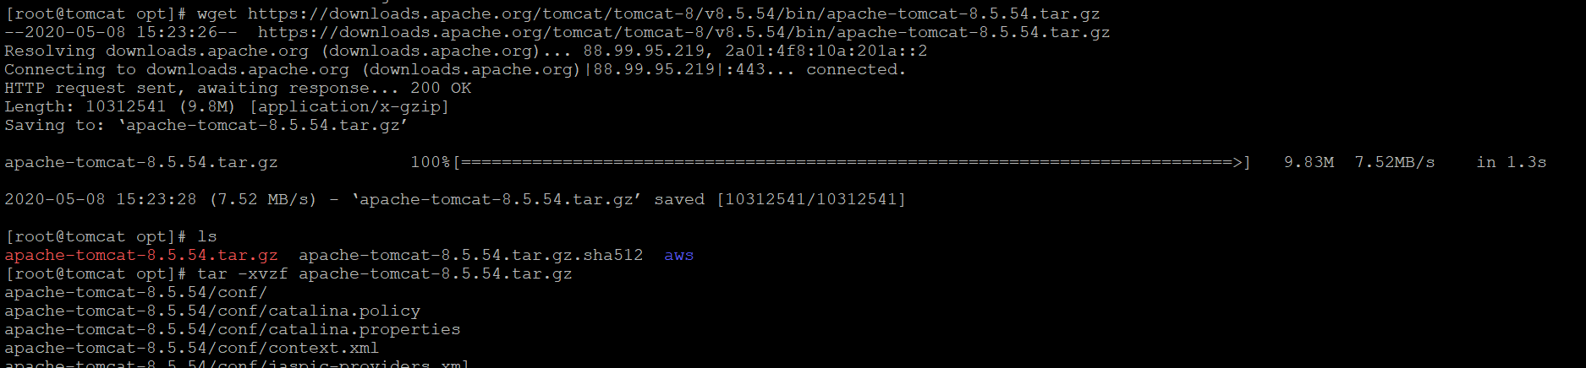

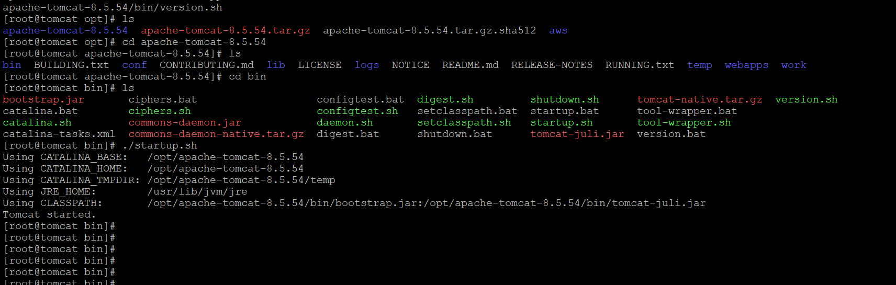

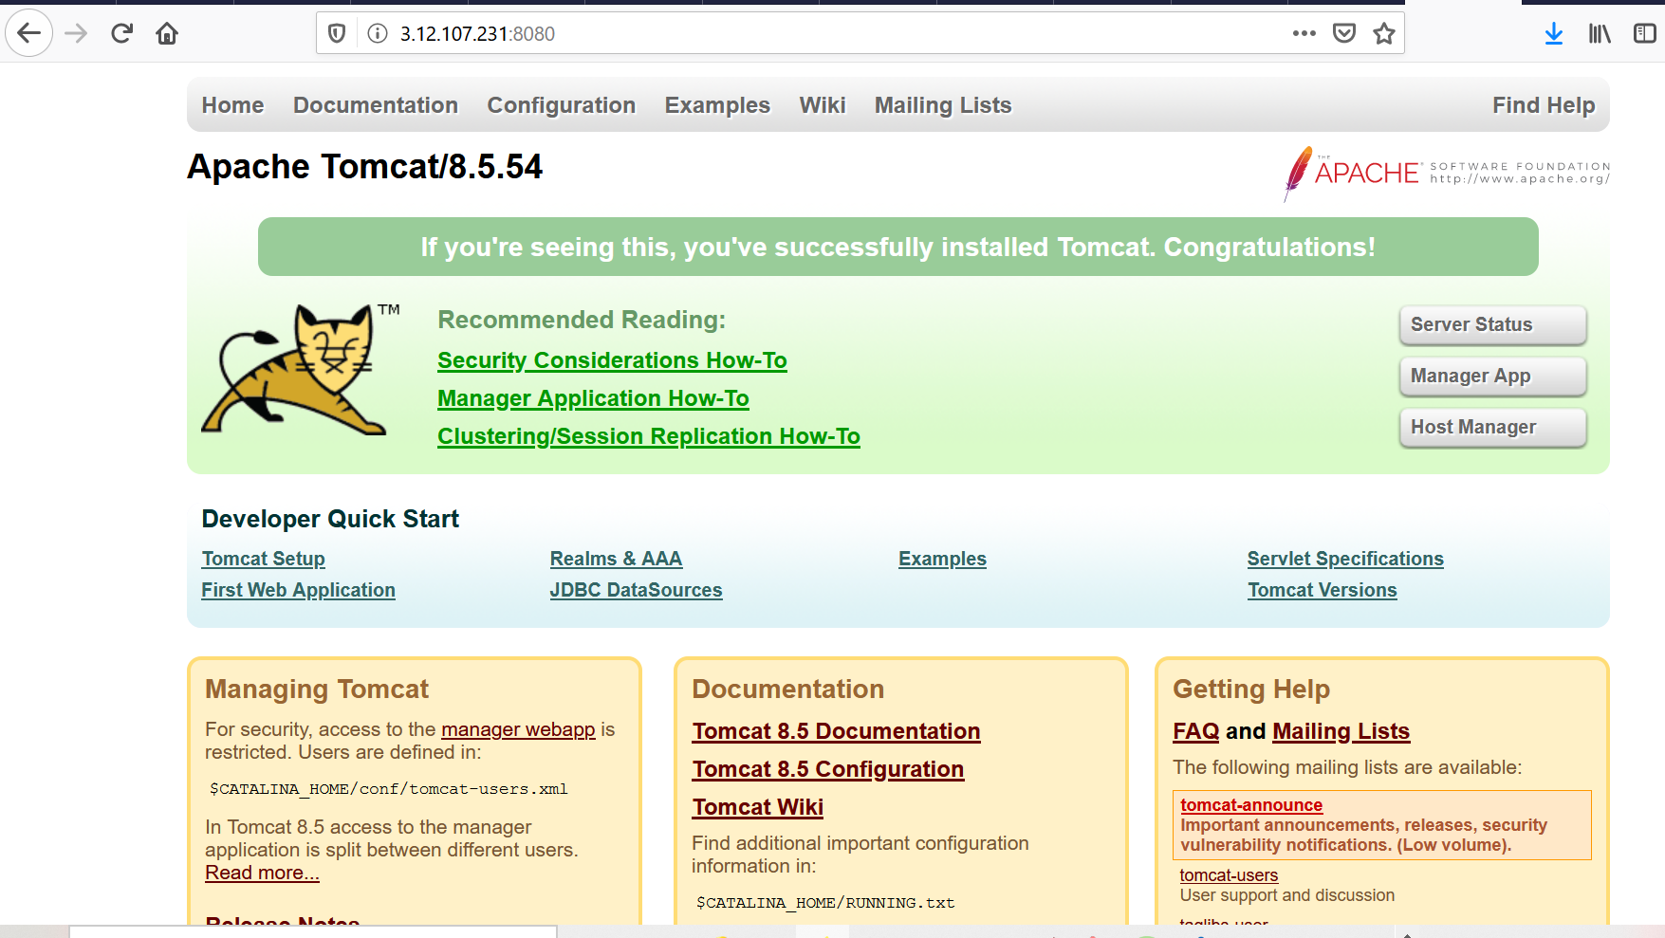

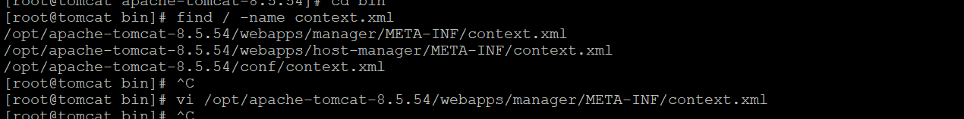

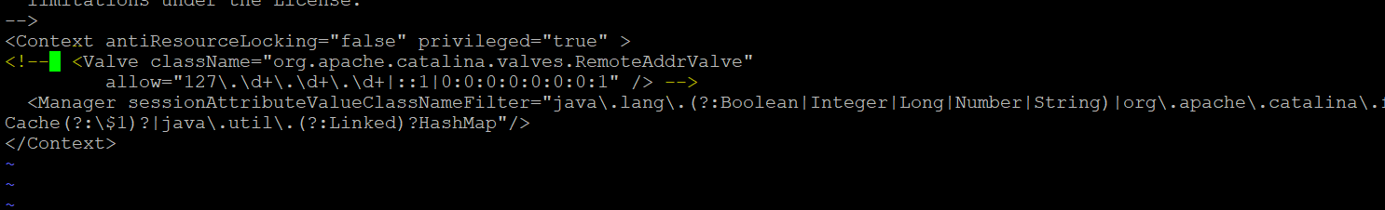







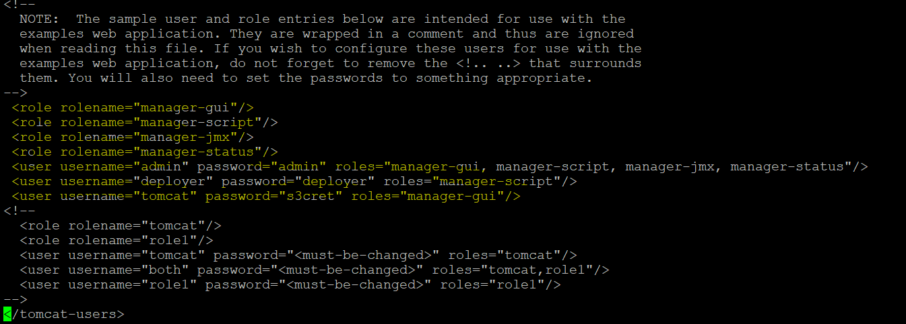

Now, Restart the server to reflect the changes of users xml.

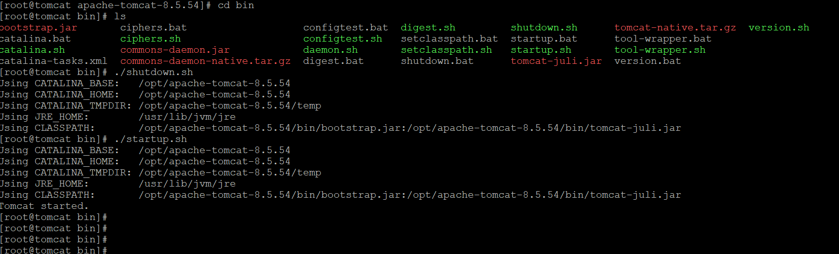

Try to login and successfully logged in ………

